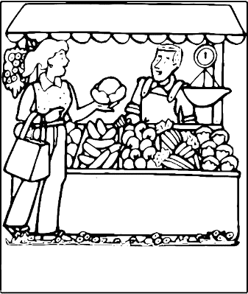
Fruits and Vegetables
  - Farm to Table Process:

- Purchasing Produce
  - Some fruits and vegetables are picked ripe and some fruits are picked green. Why?
    - ____________________________________________________________
    - ____________________________________________________________
  - Purchasing produce “in season” means they are ______________________________________
List the 3 other reasons we should buy them in season
    - ____________________________________________________
    - ____________________________________________________
    - ____________________________________________________
  - Fresh produce should be: ________________________________________________________________
  - Pick ________________________________ or a variety of _______________________ colors to obtain lots of _____________________.
  - You should __________________________________________________ and store fresh produce for no more than _______________________________ at a time.
  - Canned fruits and vegetables should not have any _________________________.
  - Frozen fruits and veggies should be _______________________ throughout, pick them up ____________________________ when shopping, They should be stored at _________ and put away quickly before they ____________________.
- RIPENING
  - Plants need _________________ and give off ______________. This is called __________________.
  - As produce ripens, complex ____________________ turn into ______________________ that makes them ________________________.
  - When the ________________________ works for too long, the produce will ______________________
  - It can be slowed by ______________________________________________________.
  - Some produce needs to _______________ before it’s _________________________ to develop its full flavor.
- NUTRIENTS
  - Fruits and Veggies are high in: ________________________________________________________
  - Most contain no _____________________, and are low in _____________________________________.
  - Because of the ______________________ found in the ___________________ we should chose ____________________ fruits over things like __________________ and packaged produce.
  - ____________, __________________________ and _____________________________ destroy the ____________________________ in produce.
- PREPARING
  - Always ____________________________________ before eating to remove ______________________ and ___________________________________
  - _______________________ produce only when needed. This helps to prevent _____________________ and _________________________ from breaking down.
  - Frozen and canned veggies are _____________ ___________________ and only need a few minutes to warm them.
  - The best ways to cook veggies are by ____________________________ or _______________________
  - If you boil veggies, you should always reduce _______________________________, ________________, and cut veggies _______________________________________
  - You can tell they are done if the texture is _______________________________. They should still have _______________ color and flavor. This retains maximum amount of ___________________________.
- ENZYMATIC BROWNING
  - Raw fruits and vegetables have __________________________ ______________________________ which is when __________________________ turns the produce _________________________.
  - It can be prevented and slowed by using __________________________________ or ______________ like ____________________________________ water to cover them. 