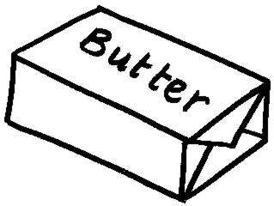
Fats Oils and Cholesterol
Fat is a necessary part of a balanced diet. It is has a very specific and important role in keeping the body healthy It is the most concentrated source of food energy, but it is not the only source of energy. Fats are solid at room temperature. Oils, are fats that are liquid at room temperature. Cholesterol is a fat-like substance that is made by the body out of fats. It is also a necessary substance for the human body to produce proper hormones.
Our bodies need small amounts of fat for various functions. Some of these functions include helping us to feel fuller longer because they remain in our stomach for a longer amount of time. Another of them being to carry the Fat Soluble vitamins A, D, E and K through the body so they can do their respective jobs. These vitamins are absorbed by the body through fat so that they can work properly. These vitamins kelp to provide energy, support the immune system, support our eye sight, and other various functions. Vitamins are essential, which in turn means that fats are essential as well. A fat-free diet can lead to health problems, specifically vitamin deficiencies.
Aside from vitamin absorption and helping us feel full, fats add flavor to food, helping to satisfy our hunger while keeping us fuller for long. Fats also serve as a reserved source of energy. It is a very concentrated source, however it is used after all carbohydrates and proteins are used. Fat helps to insulate and protect the body organs from shock and high fevers. Fats help to promote healthy skin and hair through increased vitamin content.
Fats contain a little more than double the calories that proteins and carbohydrates have (they contain 4 calories per gram). Fat has 9 calories per gram. If we eat too many fats, our digestive system cannot use these fats or get rid of them faster, resulting in obesity and/or possibly heart disease because of the raised levels of cholesterol.
Not all fats are created equal. We need to eat some fats so that we continue to maintain a healthy life style. Fats are broken down into various types; Unsaturated, Saturated, and Trans fats.
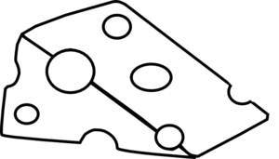
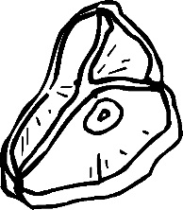
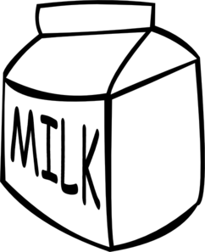
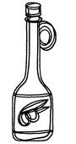
SATURATED FATTY ACIDS: These fats have a carbon chain that is full of hydrogen
atoms. Because of this, most Saturated Fatty Acids are solid at room temperature.
These fats are usually found in animal food sources such as; butter, milk, dairy
items, meats/poultry, tropical oils like coconut and palm oils, and shortening/margarine. These types of fats are the worst for us. These types of fats are bad for us because they raise the levels of bad cholesterol for us, while also raising the good types
of cholesterol as well.
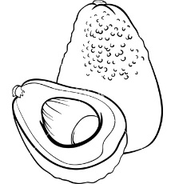
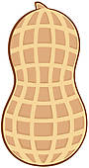
MONOUNSATURATED FATTY ACIDS: the best type of fat. It is found in both animal and plant sources. This fat contains a carbon chain that is not overly full of hydrogen atoms and 1 double bond. These fats are usually oils, or liquid fats, at room temperature.
Some sources include: Avocados, peanuts, olive oil and canola oil. These fats
help to raise our good cholesterol while lowering our bad cholesterol.

POLYUNSATURATED FATTY ACIDS: These fats are a similar to monounsaturated fats in the fact that they are not full of hydrogen atoms, however they have two or more double bonds on their carbon chain. They are usually liquid at room temperature, but start to gel or solidify once they get colder. Most vegetable oils, like corn, safflower and soybean oils are polyunsaturated fatty acids, as well as Salmon fish. These oils lower both the good, and the bad cholesterol levels in our bodies
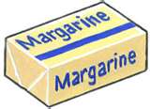
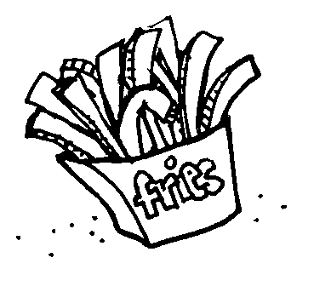
TRANS FATTY ACIDS: Most of these fatty acids start as oils and are made into a solid by the adding of hydrogen atoms, a chemical process called hydrogenation. These fatty acids are modified to prevent spoiling and make some fats easier to use. These chemical bonds are hard for our bodies to break down and process, which in turn increases our bad cholesterol levels. These can increase your risk of heart disease by clogging arteries.
Cholesterol is a necessary product that our body makes in the liver. We also can
consume cholesterol by eating fats, specifically animal fats. Cholesterol helps our bodies to build cell membranes, transport fatty acids, produce hormones and acids necessary for our bodies to digest foods.
There are two types of Cholesterol in the body that we need. One is good and one is bad. Low-density lipoproteins (LDL), or the “losers” are bad cholesterols that can build up and clog arteries, causing heart disease and possibly causing strokes. High-density lipoproteins (HDL), or the “heroes” are good cholesterols to have. They help to transport cholesterol from other parts of the body back to the liver in our blood stream so that it can be removed from the body.
When fats go bad we call them rancid. We can easily identify this spoiling of fats by the smell it produces. To prevent fats from going bad, they should be sealed or tightly covered and stored in a dry cool place.
It is suggested that we cut back on fats on in our diet to reduce the risk of heart disease, obesity and other types of disease. We can easily do this by replacing fats that are solid and saturated with oils that are liquid and easier to break down by the body, as well as eating low-fat meats and dairy that still give us good nutrients.

