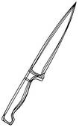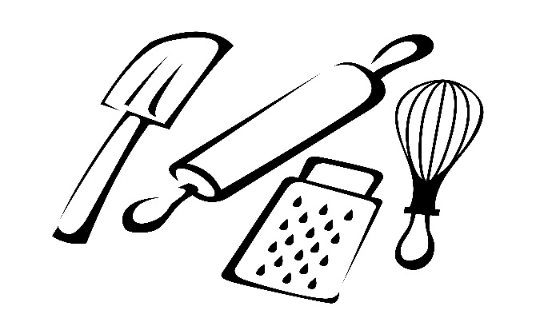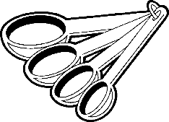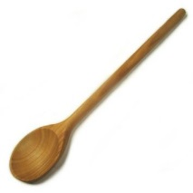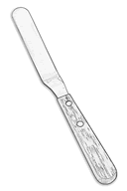Equipment: Right tool for the Right Job

|  |  |
| --- | --- |
| **TOOL NAME FUNCTION** | |
| 1. |  |
| 2. |  |
| 3. |  |
| 4. |  |
| 5. |  |
| 6. |  |
| 7. |  |
| 8. |  |
| 9. |  |
| 10. |  |
| 11. |  |
| 12. |  |
| 13. |  |
| 14. |  |
| 15. |  |
| 16. |  |
| 17. |  |
| 18. |  |
| 19. |  |
| 20. |  |
| 21. |  |
| 22. |  |
| 23. |  |
| 24. |  |
| 25. |  |
| 26. |  |
|  |  |

