APPLE PIE BITES

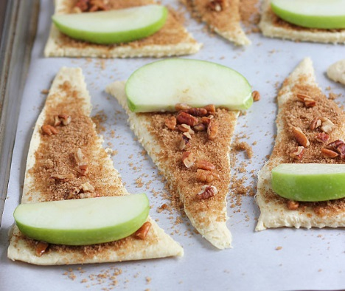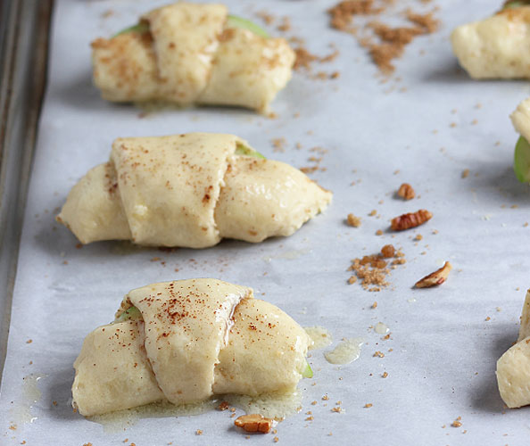

INGREDIENTS
- ¼ cup packed light brown sugar
- ¼ teaspoon nutmeg
- ¼ teaspoon cloves
- ½ teaspoon cinnamon
- 3 tablespoons butter, melted
- ⅓ cup chopped pecans (optional)
- 1 apple, cored and sliced into 8 (1/2-inch) slices
- 1 (8-ounce) can Pillsbury Original crescent rolls

INSTRUCTIONS
- Preheat your oven to 375 degrees F. Line a baking sheet with parchment paper.
- In a small bowl, combine brown sugar and spices. Set aside.
- Melt butter and toss apple slices in butter, set aside.
- Arrange crescent roll triangles on baking sheet lined with parchment paper. Evenly distribute brown sugar mixture onto each triangle.
- Sprinkle each triangle evenly with the chopped pecans if desired.
- Place an apple slice on the wide end of each triangle. Wrap crescent roll dough around each apple.
- Brush each crescent roll with remaining butter. Sprinkle lightly with additional apple pie spice.
- Bake for 10-12 minutes, or until golden brown. Cool for 5 minutes before serving.

