TIME MANAGEMENT & MEAL PLANNING NOTES
1. Time Management

MEAL PLANNING
A good meal will follow this plan:
1.
2.
3.
4.

AESTHETIC GUIDELINES:
A.
B.
C.
D.
E.

What is wrong with the following menu?
Breakfast: Milk Lunch: Chili Dinner: A hamburger
Cornflakes Crackers French Fries
Sliced Bananas Apple Milk Shake
Toast Water

What is wrong?  BREAKFAST=  LUNCH=  DINNER= | How would you change it?  BREAKFAST=  LUNCH=  DINNER=

Create a menu (Breakfast, Lunch, and Dinner) that follows the guidelines discussed. Justify each of the 6 areas of aesthetics and how the meal follows the dietary guidelines and MyPlate.
BREAKFAST  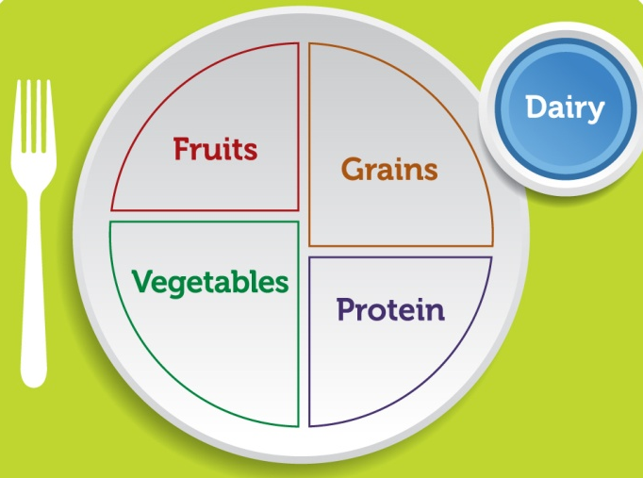 | COLOR  TEXTURE  SIZE/SHAPE  FLAVOR  TEMPERATURE  GUIDELINES/MYPLATE
LUNCH  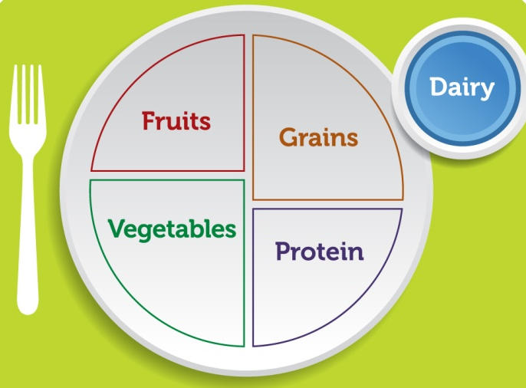 | COLOR  TEXTURE  SIZE/SHAPE  FLAVOR  TEMPERATURE  GUIDELINES/MYPLATE
DINNER  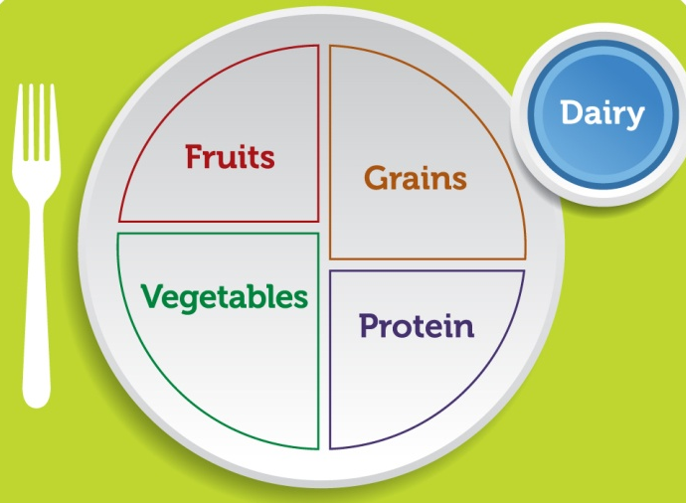 | COLOR  TEXTURE  SIZE/SHAPE  FLAVOR  TEMPERATURE  GUIDELINES/MYPLATE

