Name________________________________ Score: _________

**State Skills Review Test**

1. Which is more hazardous: a dull knife or a sharp knife (circle one)
2. Which of the following can be used to extinguish a grease fire (circle all that apply)
   1. Flour e. smother it by placing a lid over the pan
   2. Baking soda f. water
   3. Baking powder g. salt
   4. Fire extinguisher h. sugar
3. A first-degree burn should be treated with __________________________________ water
4. First-Aid for a severely bleeding cut would be to ________________________________________________
5. The first line of defense for electrical shock is to _____________________________________________
6. What happens when you mix ammonia with bleach? _________________________________________
7. Which of the following is the safest way to thaw meat?
   1. In the microwave
   2. In the refrigerator for 2-3 days
   3. On the counter in a paper bag for however long it takes to that
   4. In the sink with water for a few hours
8. You should spend at least ___________________ seconds washing your hands.
9. Which one of the following would disinfect a surface?
   1. Chlorine bleach and water
   2. Soapy water
   3. Hot water
   4. Ammonia alone
10. What are four conditions necessary for bacteria to grow (*think of what is necessary for ANYTHING to live)?
    1. ___________________ b. __________________ c. __________________ d._____________________
11. What is the temperature range for the “danger zone” _________________ - _______________
12. E-coli comes from _________________________________________
13. Salmonella comes from ____________________________________
14. Botulism comes from _____________________________________
15. Hepatitis comes from ____________________________________
16. Staph comes from _______________________________________
17. What is cross contamination? _____________________________________________________
18. Ground meats should be cooked to __________________
19. Poultry and re-heated food should be cooked to _________________
20. List at least 4 of the dietary guidelines:
21. We should increase our consumption of veggies/fruits that are _________________________________ in color
22. TRUE or FALSE: Oils are a group on Myplate
23. Each person’s caloric needs depend on their age, gender, and ____________________________
24. What are empty calories? _________________________________________________________
25. What does nutrient dense mean? __________________________________________________
26. How much exercise should adolescence get in a day? ___________________ minutes
27. 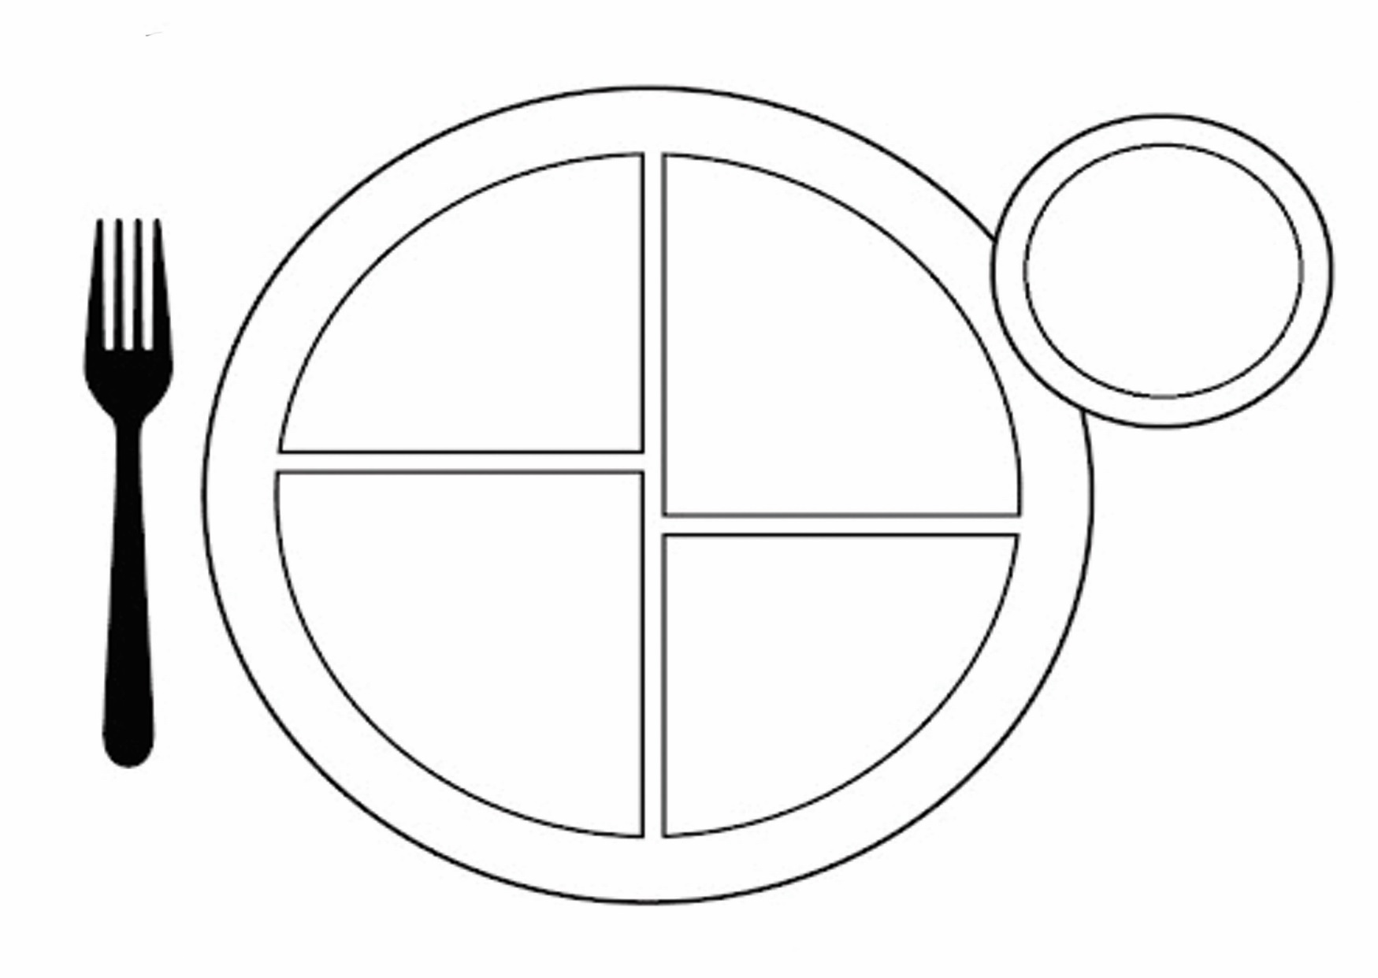Complete the Myplate picture below (6 pts)

Food Group:

Food Group:

Food Group:

Color:

Color:

Color:

Nutrient:

Tip(s):

Nutrient:

Nutrient:

Tip(s):

Tip(s):

DAIRY Serving Size:

How many servings   
you need in a day:

Food Group:

Color:

Food Group:

Nutrient:

Color:

Tip(s):

Nutrient:

Tip(s):

1. Briefly describe what the following tools do
   1. Colander/ strainer_______________________________________
   2. Peeler_________________________________________________
   3. Tongs__________________________________________________
   4. Turner_________________________________________________
   5. Pastry blender __________________________________________
   6. Wire whisk _____________________________________________
   7. Straight edge spatula _____________________________________
   8. Rolling pin _____________________________________________
2. Match the following terms to their definitions
   1. Dredge to rub on a tool that shreds food
   2. Chop to incorporate air
   3. Cream to cut into extremely small pieces, the finest size
   4. Cut-in to cut into small squares
   5. Dice to cut into smaller pieces with a knife
   6. Flour to sprinkle or coat lightly with a powdered substance
   7. Fold in to work or press dough with the palms of hands
   8. Grate to blend fat and sugar together until creamy
   9. Knead to mix flour and fat with a pastry blender
   10. Mince to remove the outside layer
   11. Peel to cook in a small amount of fat
   12. Sauté to heat to just below the boiling point
   13. Simmer to cook food in the vapor of boiling water
   14. Steam to gently combine
   15. Whip to coat food heavily with flour, bread crumbs, etc.
3. Write the abbreviations for the following:
   1. Tablespoon ___________________ d. Ounce ____________________
   2. Teaspoon _____________________ e. Pound ____________________
   3. Cup _______________________ f. Quart _____________________
4. Write the equivalents for the following
   1. 1 cup = __________ oz
   2. ¼ cup = _________ tbsp.
   3. 1 tbsp = _________ tsp
   4. 1 pt = ___________ cups
   5. 1 gallon = ________ cups
   6. 1 stick of butter = _________ cup or ___________ tbsp.
5. Double/ half the figures below
   1. 1 cup doubled__________ halved _____________
   2. ¼ tsp doubled__________ halved _____________
   3. 2/3 cup doubled __________ halved _____________
   4. 1 ½ teaspoons doubled __________ halved _____________
6. How do you measure the following:
   1. Flour:
   2. Brown Sugar:
   3. Sugar:
   4. Shortening:
7. Microwaves are attracted to which three types of molecules?
   1. Fat d. water
   2. Sugar e. bones
   3. Meat/proteins f. plastic
8. Microwave safe materials should be _____________________ in shape, and made of _____________________, plastic, or ________________________.
9. Write if each of the following are complex or simple carbohydrates
   1. Sugars _________________ e. snickers bar_________________
   2. Starches _________________ f. Rice _______________________
   3. Whole grains ______________ g. Pasta ______________________
   4. Cereal ___________________ h. fruits ______________________
10. Which sugar comes from; fruits: __________________ milk: ____________________ grapes: _______________
11. What portions of a person’s daily intake of carbohydrates should come from whole grains? ______________ %
12. Fiber works with _________________________ to move food through the digestive system and prevent constipation
13. Fiber can help prevents ____________________________________ and cancer.
14. All of the following are great sources of fiber **except**:
    1. Fruits e. milk
    2. Veggies f. beans
    3. Whole grains g. Oatmeal
    4. Popcorn
15. How many grams of fiber should you eat each day? ______________________________
16. Carbs have _______________ calories per gram
17. When cooked, pasta will _____________________ in size, and rice will _______________________ in size
18. Pasta should be cooked with the lid ___________________, while rice cooks with the lid ___________________
19. TRUE OR FALSE: Yeast is a leavening agent that works quickly, like in muffins or cookies
20. Which of the following is not a quick bread?
    1. Muffins
    2. Pancakes
    3. Crepes
    4. Cinnamon rolls
21. In products: flour provides _______________ fats provide __________________ and salt provides ___________
22. Name the two leavening agents used in quick breads:
    1. __________________________ b. _________________________
23. Fats do all of the following except
    1. Carrier for vitamins KADE d. Protect internal organs
    2. Reserve sources of energy e. Build and repair body tissues
    3. Add flavor to food f. Insulate the body
24. Fats have _____________ calories per gram
25. HDL is the good/bad cholesterol (circle one)
26. LDL is the good/bad cholesterol (circle one)
27. Fill in the chart for each fatty acid type

|  |  |  |  |  |  |
| --- | --- | --- | --- | --- | --- |
| TYPE of FAT | **HDL** | | **LDL** | | Sources |
| Raises | Lowers | Raises | Lowers |
| Saturated |  |  |  |  |  |
| Monounsatured |  |  |  |  |  |
| Polyunsatured |  |  |  |  |  |

1. Proteins have _____________ calories per gram
2. Proteins main purpose is to _____________________________________
3. There are ______ total amino acids and ______ essential amino acids.
4. Completed proteins come from _______________________ sources. They contain ________________________
5. Incomplete proteins come from ____________________________ sources
6. You can combine __________________________ with _______________________ to make a complete protein
   1. An example of this would be __________________________________________
7. Match the following functions of eggs to the food it is exhibited in
   1. Coating meat loaf
   2. Binding angel food cake
   3. Thickening custard/pudding
   4. Leavening mayonnaise
   5. Emulsifying breading on chicken
8. Water-soluble vitamins include: _________________________________________
9. The fat soluble vitamins are: ____________________________
10. The vitamin that can help prevent birth defects that spinal bifida is called ________________________
11. TRUE or FALSE: Too many vitamins can be toxic to your body
12. When fresh fruits turn brown it is called e_____________________________ b_____________________
13. Which of the following is the **worst** cooking method for preserving nutrients?
    1. Microwaving c. boiling
    2. Steaming d. stir frying/sautéing
14. Name the macro-minerals we talked about and where to find them ____________________________________  
    ___________________________________________________________________________________________
15. Name the micro-minerals and where to find them: __________________________________________________  
    ___________________________________________________________________________________________
16. What are the electrolyte minerals and what do they do?______________________________________________  
    ___________________________________________________________________________________________
17. Calcium deficiency leads to __________________________________________________
18. Iron deficiency leads to ____________________________________________________
19. It is recommended that adults have ________________________ servings of milk each day
    1. What is classified as a serving? ______________________________________
20. What is homogenization? ______________________________________________________________________
21. What is pasteurization? ________________________________________________________________________
22. What is fortifying? ____________________________________________________________________________
23. What many ounces of water is recommended each day? _____________________________________________
24. TRUE OR FALSE: Water is the most important nutrient
25. Water is used to carry ______________________________ products through the body and regulate body ________________________________________ through sweating.
26. What are the three energy producing nutrients?