PLACE SETTINGS and ETIQUETTE
A cover is: _______________________________________________________________________________
How do you know what to set the table for? ______________________________________________
_________________________________________________________________________________________
B_________________________ M__________________________ W_______________________
Positioned from ____________________________ to _________________________
Work from the ___________________________ to the ______________________________
Label the place setting cover with the appropriate names for each picture shown.
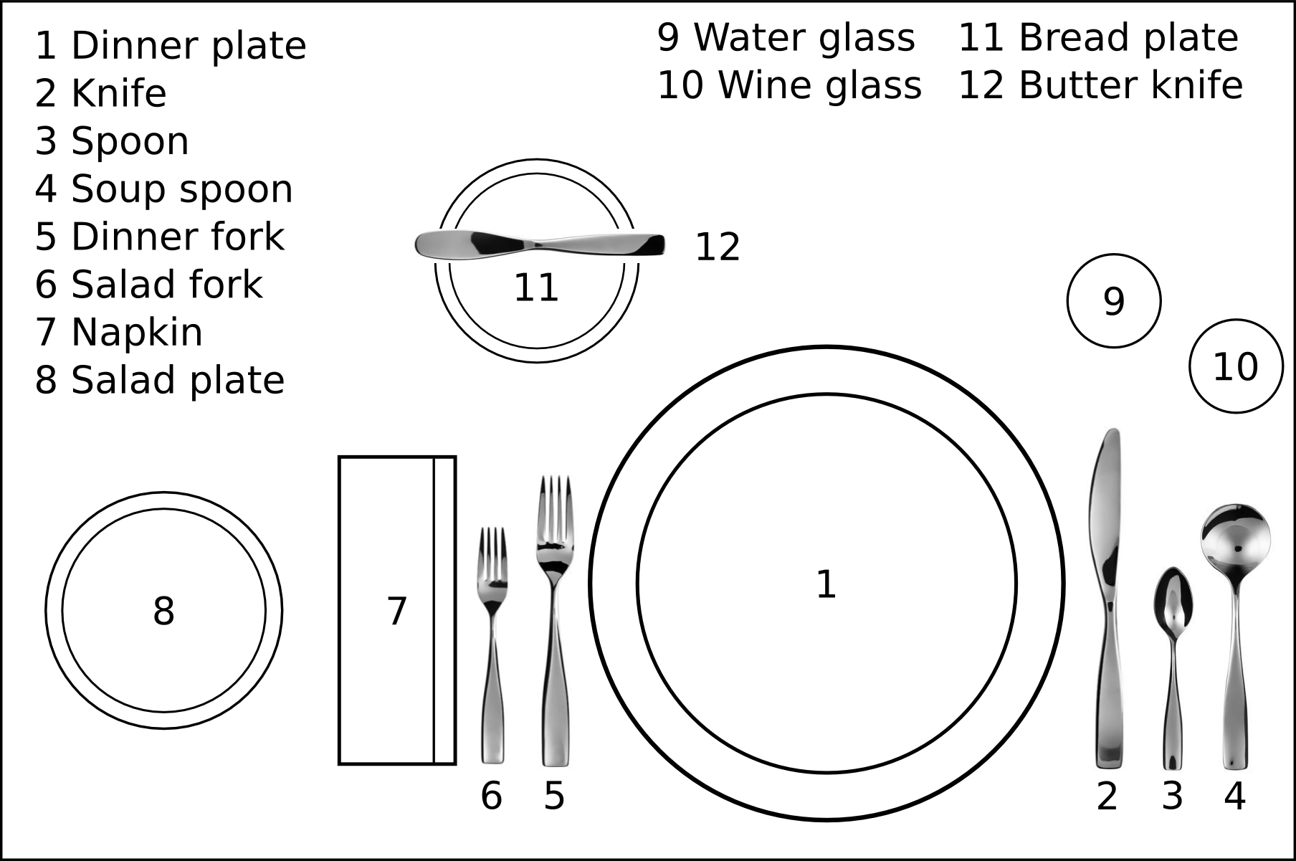
1. 5. 9.
2. 6. 10.
3. 7. 11.
4. 8. 12.
ETIQUETTE
Tip amount :______________________________________________________________________________
Napkin should be placed:
During the meal _______________________________________________________________________
When using the bathroom _____________________________________________________________
When you are finished _________________________________________________________________
Flatware, when fished should be placed
American _________________________________________________________________________
Continental ________________________________________________________________________
Cell phones: _____________________________________________________________________________
Elbows: __________________________________________________________________________________
Chewing Food:___________________________________________________________________________
Passing food:____________________________________________________________________________

Food Service Styles: DEFINITION Restaurant Example
American: ______________________________________________________________ ___________________
French:________________________________________________________________ ___________________
Russian:________________________________________________________________ ___________________
Wagon:________________________________________________________________ ___________________
Butler:_________________________________________________________________ ___________________
Family Style:____________________________________________________________ ___________________
Buffet:_________________________________________________________________ ___________________
Fast/Cafeteria:___________________________________________________________ ___________________

