Kitchen Hazards and First Aid Tips

Hazard #1- ELECTRICAL SHOCK Hazard #4- TRIPS, SLIPS, and FALLS
- ___________________________________ 1. __________________________________
- ___________________________________ 2. __________________________________
- ___________________________________ 3. __________________________________
- ___________________________________ 4. __________________________________
- ___________________________________ 5. __________________________________
FIRST-AID: ________________________________
__________________________________________
Hazard #2- KNIVES AND CUTS Hazard #5- CLEANING SUPPLIES AND POSININGS
- __________________________________ 1.__________________________________
- __________________________________ a.________________________________
- __________________________________ 2.__________________________________
- __________________________________ 3.__________________________________
- __________________________________ 4. __________________________________
- __________________________________ FIRST-AID:___________________________
FIRST-AID: ____________________________ ____________________________________
_____________________________________
Hazard #3- Grease Fires and Burns
- _________________________________
- _________________________________
- _________________________________
- _________________________________
- _________________________________
- _________________________________
  - ___________________________
  - ___________________________
  - ___________________________
FIRST-AID: ___________________________
_____________________________________

CLEANING AND SANITIZING
- Keep all work surfaces ______________________________________
Clean:______________________________________________
- Disinfect/sanitize work surfaces to prevent _______________________________
  - Disinfect: ________________________________________________________
  - Cross-contamination: ____________________________________________
- Clean and sanitize surfaces ____________________________________________
- Always use sanitizers and cleaners ______________________________________
- Store __________________ for cleaning food spills in _______________________ when you are not using them, never in__________________________________
- Use a __________________________ to check the strengths and ensure it’s working correctly.
- To properly sanitize:
  - ________________________________________________________
  - ________________________________________________________
  - ________________________________________________________
  - ________________________________________________________

GERMS
- Stop the spreading of germs by using __________________________________________ and only use it _______________________________
- Pathogens= __________________________________________________________________
- 3 types of food contaminates:
1. Biological ___________________________________________________________
2. Chemical____________________________________________________________
3. Physical______________________________________________________________

HAND WASHING
______________ SECONDS
- Wet __________________________________________________________
- Apply _______________________________________
- Scrub hands and arms for at least ____________________________________________
- Rinse _____________________________________________
- Use an ______________________________________________ after washing
hands
- Wait for the antiseptic to dry before ___________________________________________
- Singing the ABC’s, Twinkle-Twinkle Little Start, or
Happy Birthday can help you gage your time
- Dry hands and arms with ____________________________________________________
- Do not use ___________________________________________________________ to dry hands (these contain bacteria)
- Use the ______________________________________ to turn off the faucet and open doors
- If your work place has a handwashing sink: the handwashing sink is to be used for __________________________________________
- Never use the designated handwashing sink for other purposes.
WEARING GLOVES
- Avoid bare-hand contact with ________________________________________________
- Wear gloves if you have ______________________________________________________
  - A bandage must cover the wound completely and a glove must be worn over the bandage.
- Use the correct size _________________________________________________________
- Never ____________________________________________________________________
- Wash hands ___________________________________________ and _________________________________________________________________________
- Change gloves ___________________________________________________________
CLOTHING, HAIR and JEWELRY
- Wear a _____________________________________________________________________ to prevent spreading of germs
- Tie ___________________________________________________________________________
- Remove all ___________________________________________________________________
  - The ONLY exception is __________________________________________________

DISHWASHING
- Wash dishes in the following order:
  - ____________________________________________________________________
  - ____________________________________________________________________
  - ____________________________________________________________________
  - ____________________________________________________________________
  - ____________________________________________________________________
  - ____________________________________________________________________
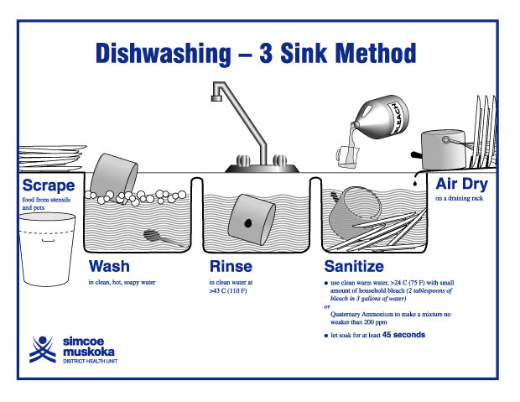
- Dish Machines are used in the industry to quickly clean and sanitize dishes
  - _______________________________________________________________________
  - _______________________________________________________________________
  - _______________________________________________________________________
  - _______________________________________________________________________
- Store clean dishes _________________________________________________________
- Store at least _____________________________________________________________
- Store ____________________________________________ on a clean, sanitized surface.
- If storing utensils vertically, store them with _____________________________________
- TRASH
- Remove the garbage _______________________________________________________
- Do not clean garbage containers ____________________________________________
- Use ________________________________________________________
- Clean _______________________________________________________________________ often.
- Close ________________________________________________________ containers.

